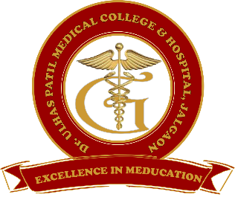**Godavari Foundation’s**

**DR. ULHAS PATIL MEDICAL COLLEGE & HOSPITAL,**

**Recognized by Medical Council of India, Approved by Central Govt. of India, New Delhi,**

**Letter no. MCI-34(41)/2012-med./158127, dated 05/02/2013**

**Affiliated to Maharashtra University of Health Sciences, Nashik [College Code-1306]**

**Jalgaon-Bhusawal Road, NH-6, Jalgaon Kh, Tal. & Dist. Jalgaon 425309**

**Tel. No. (0257)2366657, 2366678 Fax No. 0257-2366648**

**Email ID :** [**dupmcj@yahoo.in**](mailto:dupmcj@yahoo.in) **Web Site :** [**www.dupmc.ac.in**](http://www.dupmc.ac.in)

**4.3.5 In-person and remote access usage of library and the learner sessions/library usage programmes organized for the teachers and students (data for the preceding academic year)**

Library is the important resource for medical students and staff. DPUMC is having well established library having remote access to its users.

DUPMC organizes awareness sessions for teachers and students for how to use remote access facility of library every year. This awareness is organized for all students and teachers.

**Remote Users**: On-campus remote users are possessed significant experience with library research and familiarity with electronic resources, and demonstrate relatively high success in using information technology.

A library is a set of resources, which include human services as well as the entire spectrum of media. Libraries have physical components such as space, equipment, and storage media; intellectual components such as collection policies that determine what materials will be included and organizational schemes that determine how the collection is accessed; and people who manage the physical and intellectual components and interact with users to solve information problems.

A well-equipped library serve a practical role in sharing expensive resources. Physical resources such as books and periodicals, films and videos, software and electronic databases, and specialized tools such as projectors, graphics equipment and cameras are shared by a community of users.

Library learning session for 1st year MBBS students and staff.

The library learning session was organized by the Central Library every year in the first week of 1st MBBS session

The Central Library has organized a learning session for 1st MBBS Students and staff at Lecture Hall no. 1. All the faculty and students of 1st MBBS attended this session. The session began with worship of lord Dhanwantari Pooja with lamp lighting. The students were briefed about the library functions, library resources, library services, library facilities and library rules. The library learning session was focused on the How to use the library resources by the students throughout the year. The students were briefed about some important functions. Basic The librarian introduce some basic functions, resources and services useful for student who joined the MBBS course newly. They are introduced how to use the library services, how to open a library account, issue and return the books, use of journals as well as how to use open access web sites.